Term 1 Week 9 Lesson 2_ Reading Scatterplots worksheet.

 | 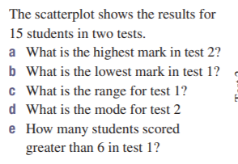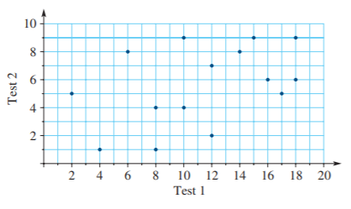
 | 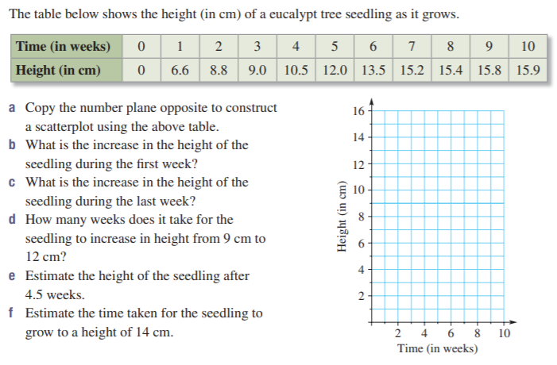
 | 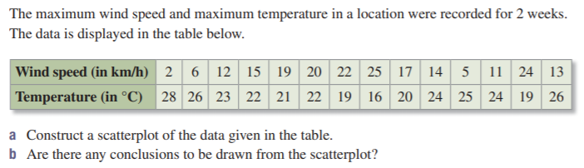
4. | For those up for challenge!- see next page  